Fully Automatic: Plug-in Automation

Introduction
The vast majority of us use plug-ins instead of hardware when mixing, it would seem that the times they are a-changin’! Likewise, gone are the days when engineers would record the effects in real time – now you can automate the controls of a plug-in just like you automate a fader ride!
For this tutorial you can use the audio from the AIR Talkbox plug-in tutorial here. Talkbox is a plug-in that benefits greatly from a little automation so please try it out.

Lock & Load
In order to automate a plug-in’s controls you first need to enable the automation, at this stage it is worth pointing out that not all controls can be automated. There are two ways to enable automation, either open the plug-in automation dialogue window (see images below) or use my preferred technique – a shortcut of of course! Hold Command_Option_Control (mac)Control_Alt_Start (windows) and click on the control you want to automate (see below).
Dialogue Window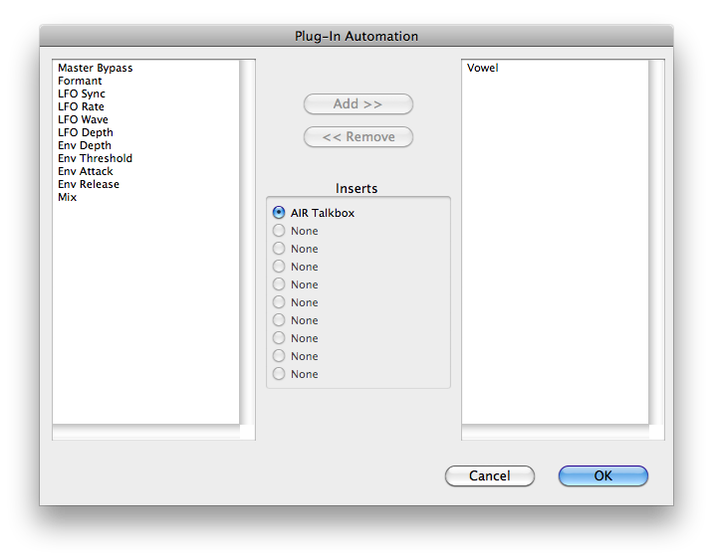

Using the shortcut
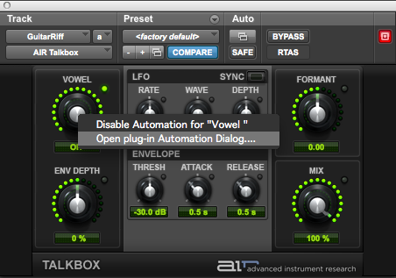

Semi-Automatic
So now the control is ready to be automated we need to switch over to the edit window to draw the automation data. Alternatively, you could set the track’s automation to ‘write’ mode (or touch or latch) and play the track through whilst adjusting the controls in real-time.
Quick Tip: Use shortcut Command_= (mac) Control_= (windows) to toggle between Mix and Edit windows
In order to display the control’s automation editing lane you can click the control whilst holding shortcut Command_Control (mac) Control_Start (windows), or select the relevant option in the track-view menu as below.
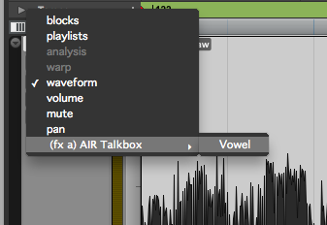
Once you’re there, you are ready to draw in, or edit your recorded automation data. Experiment with the pencil tool to add curves and the grabber tool for adding/editing individual breakpoints. You may find switching between slip and grid modes useful depending on the material you are working with.
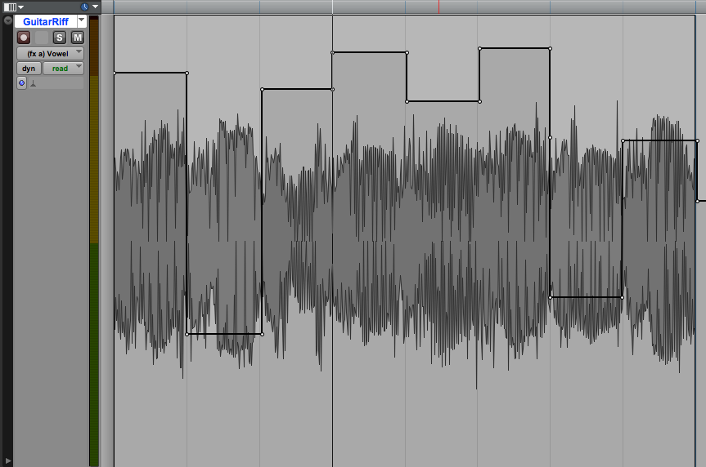

Getting Hands-on
If you want to record the automation like I mentioned earlier either by using your mouse or an external controller you should first check that plug-in automation is ‘write enabled’ in the automation window. You can find the window in Window>Automation or Command_4(numeric keypad) (mac) CTRL_4 (numeric keypad) (windows).
Once this global setting is enabled in addition to the track level setting (see images below) all you need to do is play back (note were not using record here) the session and get busy twiddling those dials.
